epointment

Software Requirements Specification
Release 1.0
6/21/2000

University of Texas at Dallas
Independent Study: Developing e-commerce system

Casey Chesnut
Clinton Chadwick

Table Of Contents

1. Introduction ............................................................ 4
1.1 Purpose of SRS
1.2 Scope of product
1.3 Definitions, acronyms, and abbreviations
1.4 References
1.5 Overview of rest of SRS
2. General Description ............................................................ 5
2.1 Product perspective
2.2 Product functions
2.3 User characteristics
2.4 General constraints
2.5 Assumptions and dependencies
3. Specific Requirements
3.1 Functional Requirements ............................................................ 6
3.1.1 Find Provider ............................................................ 11
3.1.1.1 Introduction
3.1.1.2 Inputs
3.1.1.3 Processing
3.1.1.4 Outputs
3.1.2 Manage Schedule ............................................................ 12
3.1.3 Manage Appointment ............................................................ 15
3.1.4 Register ............................................................ 21
3.2 External Interface Requirements ............................................................
3.2.1 User interfaces
3.2.2 Hardware interfaces
3.2.3 Software interfaces
3.2.4 Communication interfaces
3.3 Performance Requirements ............................................................
3.4 Design Constraints ............................................................
3.4.1 Standards compliance
3.4.2 Hardware limitations
3.4.3 Software limitations
3.4.4 Environmental
3.5 Attributes ............................................................
3.5.1 Availability
3.5.2 Security
3.5.3 Maintainability
3.5.4 Transferability/conversion
3.6 Other Requirements ............................................................
3.6.1 Database
3.6.2 Operations
3.6.3 Site adaptation

List Of Figures

Analysis Use Case Diagram ............................................................ 6

Lower Level Use Case Diagrams
Register ............................................................ 7
Manage Schedule ............................................................ 7
Manage Appointment ............................................................ 8

Analysis Class Diagram ............................................................ 9

Sequence Diagrams
Find Provider ............................................................ 11

Manage Schedule:
Create Schedule ............................................................ 12
View Schedule ............................................................ 13
Change Schedule ............................................................ 14

Manage Appointment:
Request Appointment ............................................................ 15
Confirm Appointment ............................................................ 16
Change Appointment ............................................................ 17
Cancel Appointment ............................................................ 18
Appointment Reminder ............................................................ 19
View Appointment ............................................................ 20

Register:
Create Profile ............................................................ 21
Login ............................................................ 22
Change Profile ............................................................ 23
1. Introduction

  - Purpose of SRS
This document is the Software Requirements Specification for the epointment online appointment system. It details the results of the analysis effort performed by the developers of epointment. This analysis effort reflects the intentions of epointment’s Business Plan, as well as providing the basis for design and prototyping of the online appointment system. Finally, this document will also be referenced during implementation and testing of the final system, to be performed at a later iteration.

1.2 Scope of product
The system initially provides for a doctor/patient online appointment system. The schedule is a dynamically generated HTML page hosted at http://www.epointment.to. It is created from information submitted by the doctor through online forms. The patient uses the system to find a doctor and view their schedule. The schedules shows information such as the doctor’s working hours, lunch breaks, holidays, vacations, unavailable appointment times, etc… The patient then uses the system to request an appointment at an available time. The doctor looks at a master view of the schedule and approves the requested appointments. An email message is sent to the patient to confirm the appointment that they requested.

1.3 Definitions, acronyms, and abbreviations

DBMS DataBase Management System
HTML HyperText Markup Language
HTTP HyperText Transfer Protocol
IEEE Institute of Electrical and Electronics Engineers
MIME Multipurpose Internet Mail Extensions
SRS Software Requirements Specification
SSL Secure Socket Layer
TBD To Be Determined
TBR To Be Resolved
UML Unified Modeling Language
UTD University of Texas at Dallas
LAN Local Area Network

1.4 References
This document conforms to the IEEE 830 Standard for Software Requirements Specifications. The UML artifacts are compliant with UML Version 1.1.

1.5 Overview of rest of SRS
The remainder of this document is organized as follows: Section 2 presents a General Description of the system. Specific requirements are presented in Section 3. The specific requirements are categorized as functional, external interface, performance, design constraints, attributes, or other requirements. The functional requirements section includes the UML analysis diagrams. The UML analysis artifacts are use case diagrams, sequence diagrams, and an analysis-level class diagram. A second iteration would include use case texts and operations specifications (pre/post-conditions).

2. General Description

2.1 Product perspective

The proposed system allows doctors to make their schedules available online so that patients can find doctors and make appointments from the convenience and privacy of their web browser.

2.2 Product functions

- Find Doctor – A patient uses this interface to search for a doctor. Ultimately, the patient might be able to search for doctors based on appointment availability time (e.g. I need to find a doctor that takes appointments early in the morning).

- Patient Schedule – This is a limited view of the schedule in which patients request appointments. It does not show what other patients have made appointments for. Approved and requested appointments are represented as unavailable appointment times.

- Doctor Schedule – This is a master view of the schedule that shows detailed appointment information. Some of this information should be hidden from the patient view. Doctors can use this view to approve requested appointments.

- View Appointments – A registered patient uses this interface to see what appointments he/she has scheduled.

2.3 User characteristics

The users of this system are assumed to have a basic understanding of the Internet.

2.4 General constraints

The prototype system has to be non-profit because of the academic constraints of the University of Texas at Dallas.

2.5 Assumptions and dependencies

Tailored out of this document.
3. Specific Requirements

3.1 Functional Requirements

The functional requirements were derived from the following use case diagram. Use case diagrams represent the functional interactions of a system. The stick figures represent the actors, which are external to the system and interact with the system through interfaces. The actors of the online appointment system are the Patient and the Provider. The Patient uses the system to schedule appointments to obtain services from Providers. The ovals are individual use cases that represent the functions the system performs to provide the services that the actors desire. The primary use cases of the online appointment system are: Find Provider, Manage Schedule, Manage Appointment, and Register. The Patient interacts with the following use cases: Register, Manage Appointment, Find Provider. The Provider interacts with the following use cases: Register, Manage Appointment, Manage Schedule.

High Level Analysis Use Case Diagram

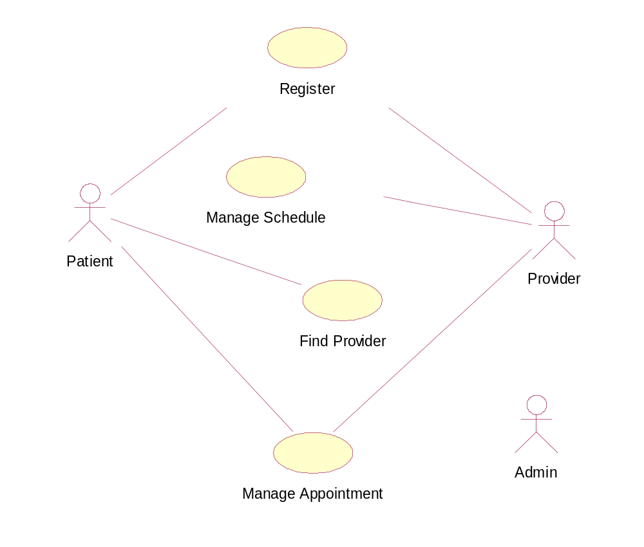

Some of the high level use cases have been decomposed into their own use case diagrams (e.g. Register decomposes to lower-level use cases: Create Profile, Login, Change Profile).

Register Use Case Diagram
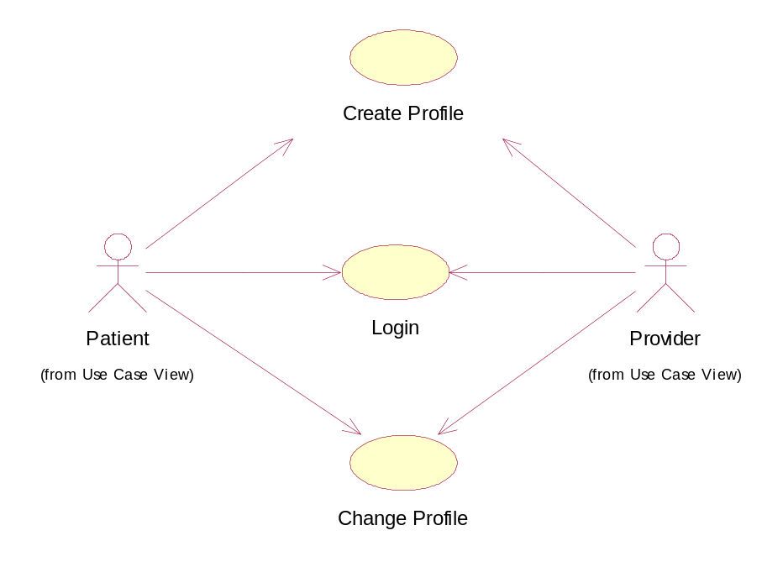

Manage Schedule Use Case Diagram
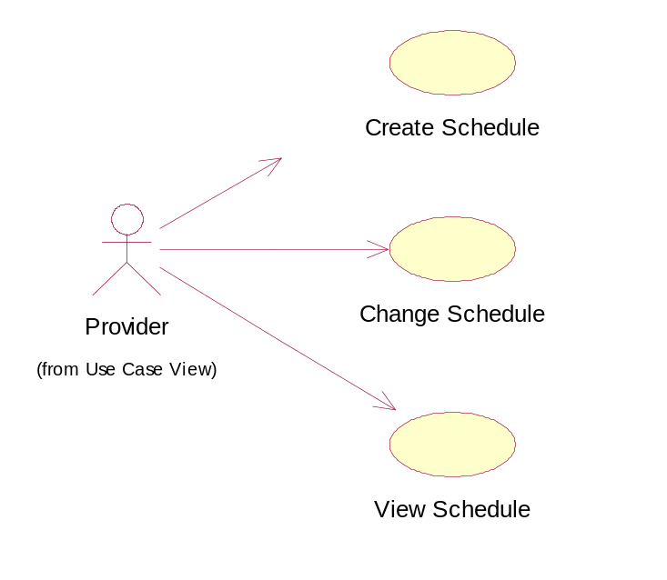
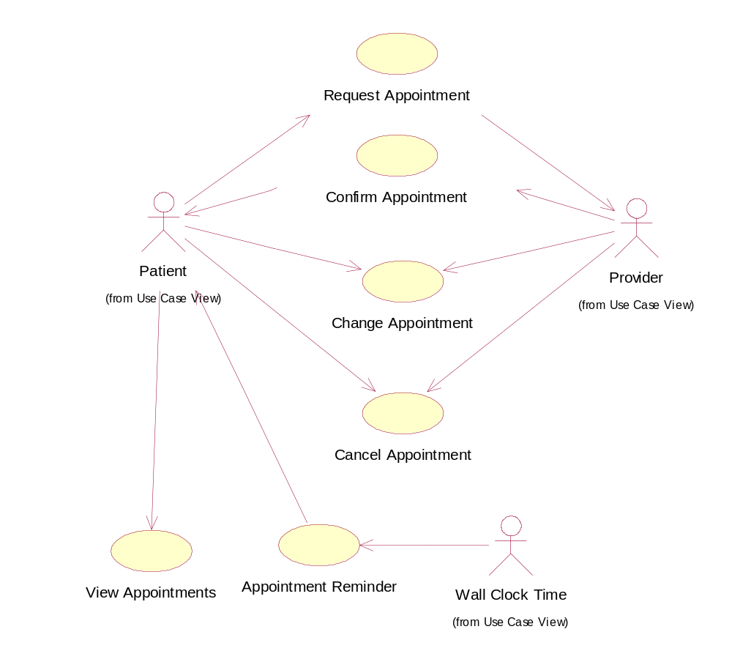
Manage Appointment Use Case Diagram
The online appointment system was also modeled as an analysis-level class diagram. Class diagrams represent the static associations between objects in the system. Analysis-level class diagrams avoid design, and only concentrate on the concepts related to the domain. Furthermore, distinguishing between classes and attributes is deferred until detailed design. Although, the leaves of the analysis-level class diagram are typically folded up into the parent object to become an attribute (e.g. Username would be an attribute of the Registered User class). Also, depending on the architecture chosen, this domain model would become the basis for designing the business layer of an enterprise architecture.
Patient and Provider are external actors of the system which would also be represented as objects in the system, derived from the Registered User class. Anonymous patients that are using the system to find providers, will not be represented as objects in the system. Patient, Provider, Schedule, and Appointment would be the primary objects in the system, and would be the most complex shown from the multiple relationships that they share. Another interesting item is how many attributes Appointment and Non Work Hours share. Design might modify these items such that Appointment is a specialization of Non Work Hours as to avoid code duplication during the Implementation phase. UML design artifacts, such as collaboration diagrams, would provide the exercise to flesh out the complete set of attributes and methods necessary to support the system. This analysis artifact helps the transition from analysis to design.
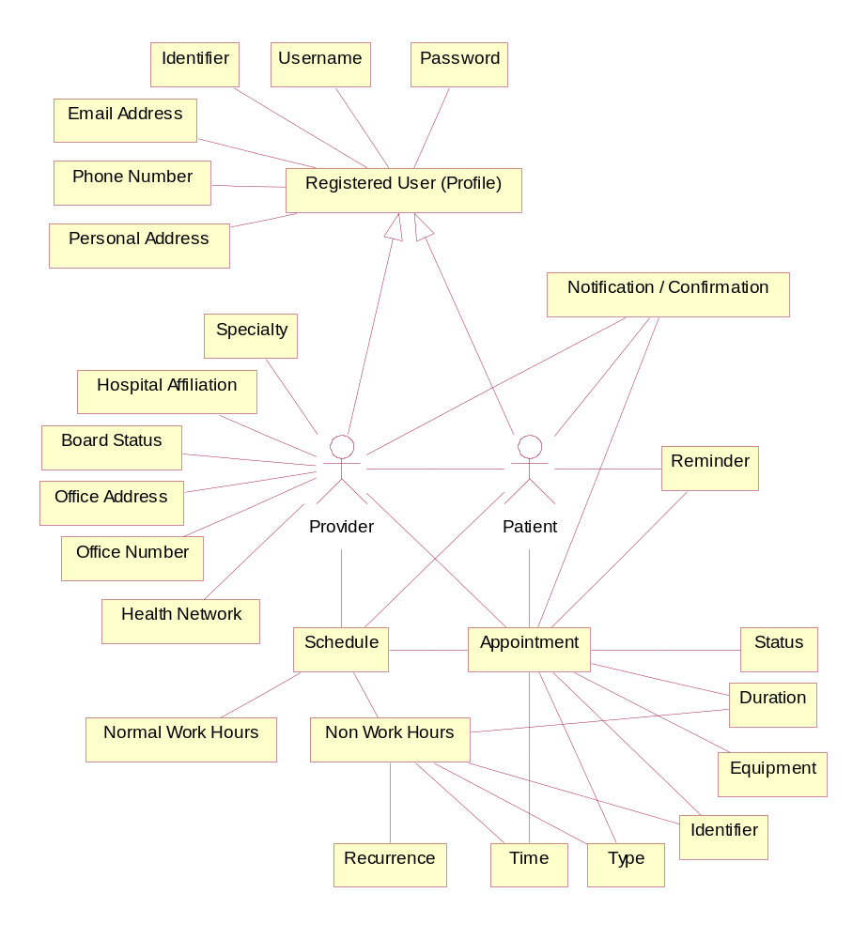

Finally, the dynamic aspects of the system are modeled as sequence diagrams. Each use case has its own corresponding sequence diagram. The sequence diagram shows the flow of data between the system and external actors through interfaces, as well as for the flow of data and message calls between objects internal to the system. Data cannot flow between actors and objects unless they have the appropriate association represented in the class diagram. Only some of the objects of the class diagram are required to support the function of each individual use case. The scenarios represented are the most common path through the system and do not detail alternate scenarios. The scenarios are also time dependent and happen in sequence. The transitions internal and external to scenarios might be either synchronous or asynchronous.

3.1.1 Find Provider

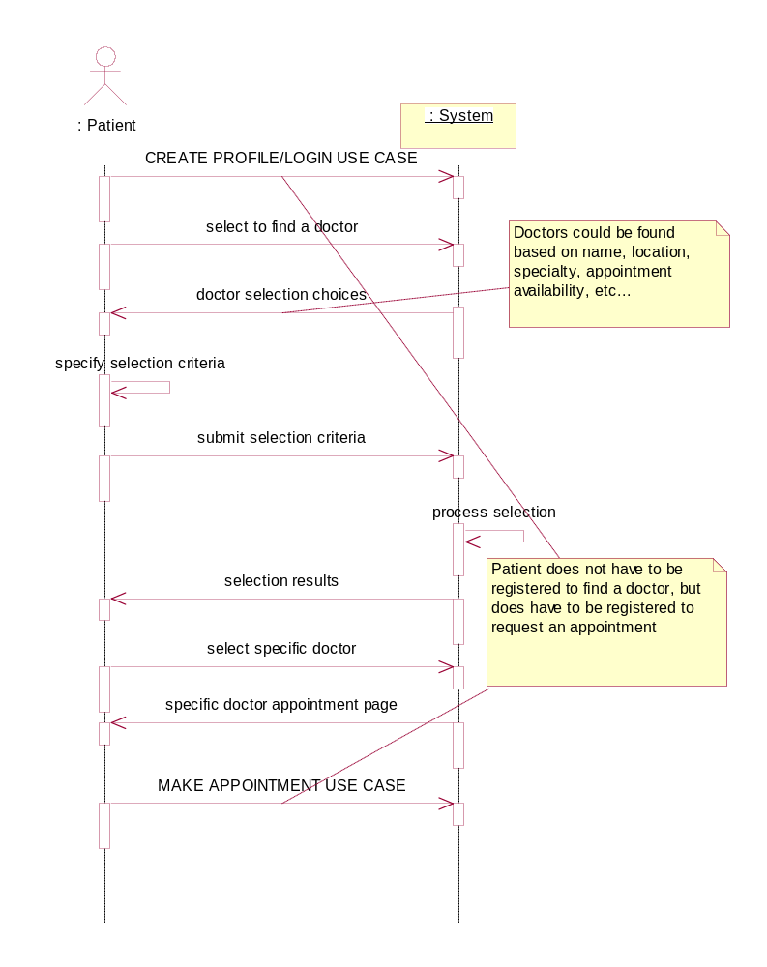

3.1.1.1 Introduction
Customers shall be allowed to search for providers by a variety of criteria. This criteria shall be by zip code and specialty but must be extensible so that any it is possible to sort or search on any data field.

3.1.1.2 Inputs
The user would input the searching criteria/values and the sorting criteria.

3.1.1.3 Processing
The system performs a search on the database of provider

3.1.1.4 Outputs
The user is presented with a list of providers that match the searching criteria sorted as defined by the sorting criteria. By clicking on any doctor listed the user is taken to that doctor’s main appointment page.
3.1.2 Create Schedule
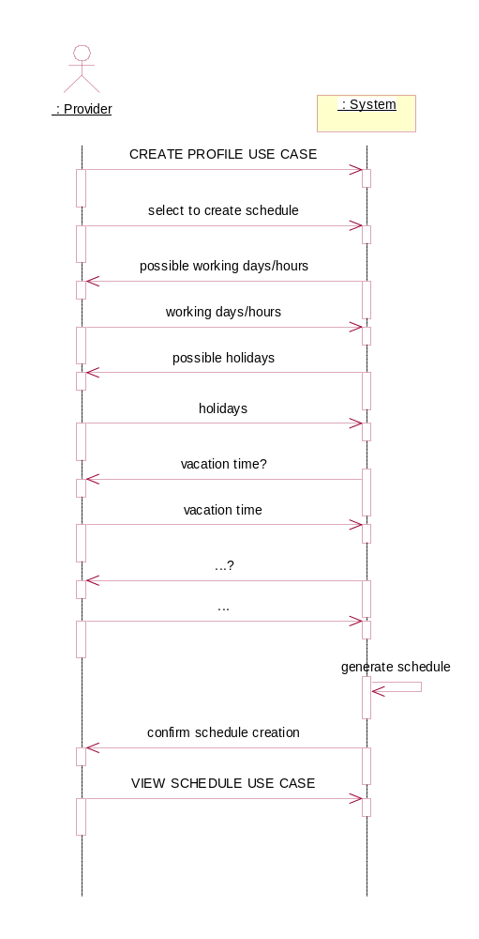

3.1.2.1 Introduction
Providers shall be able to define their schedule. This schedule shall determine when patients can make appointments to see that provider. The schedule shall be exception based. The schedule consists of the normal weekly schedule and then will contain exceptions to this normal schedule.

3.1.2.2 Inputs
The provider shall initially enter his/her normal weekly schedule. Then the provider will enter exceptions to this normal weekly schedule. These exceptions will take the form of a day/time and duration. Exceptions may reoccur. Reoccurrences may be weekly, monthly, or annually.

3.1.2.3 Processing
The system will create an internal representation of the specified schedule.

3.1.2.4 Outputs
The system will confirm the schedule addition
3.1.2 View Schedule
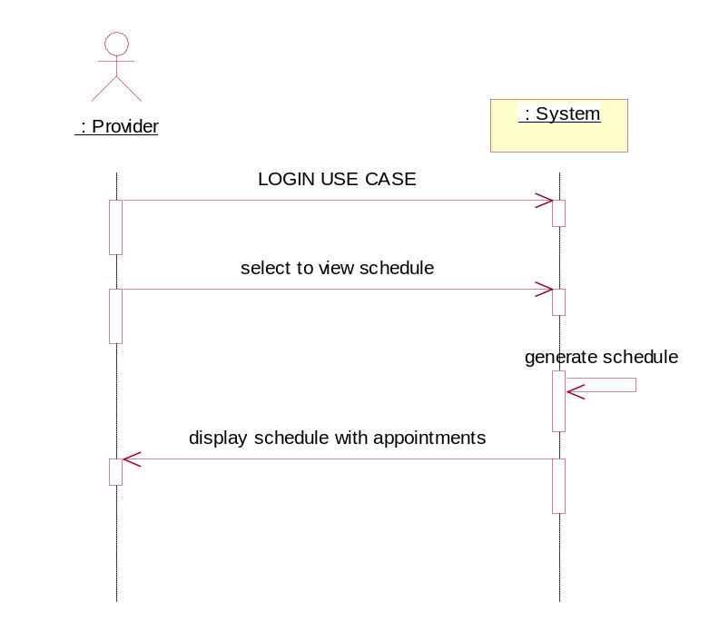

3.1.2.1 Introduction
The provider shall be able to view his/her schedule. This schedule shall be in the format of a calendar. The default view will be a weekly view, and the provider shall be able to view the schedule for the current week or any week in the past/future. The provider shall have the ability to navigate weeks by using a month view on the same page.

3.1.2.2 Inputs
The provider will choose to view his/her schedule

3.1.2.3 Processing
none

3.1.2.4 Outputs
The schedule view as described above.
3.1.2 Change Schedule
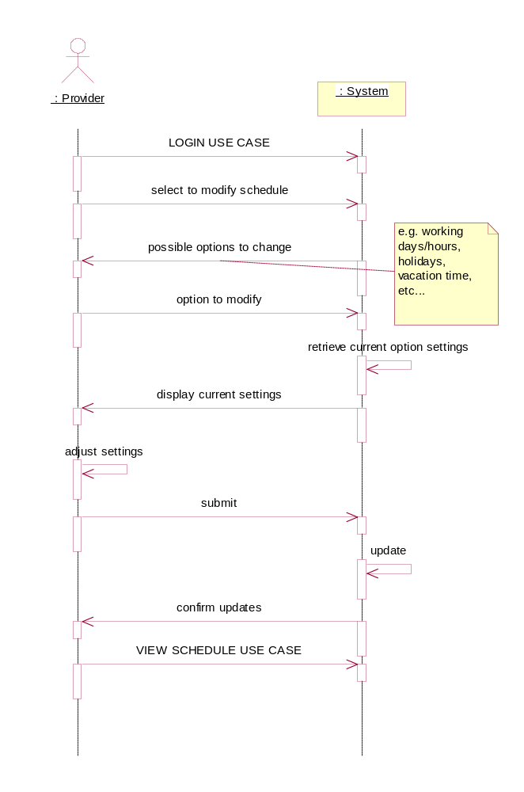

3.1.2.1 Introduction
Providers shall have the ability to change their schedule much in the way they originally created it. They can either change their standard weekly schedule or add/change/delete exceptions.

3.1.2.2 Inputs
The provider chooses to either modify standard weekly settings or to modify exceptions. The provider will then provide the modification values.

3.1.2.3 Processing
none

3.1.2.4 Outputs
The system displays confirmation of the modification
3.1.3 Request Appointment

3.1.3.1 Introduction
The patient uses a web browser to schedule an appointment pending the providers approval.
3.1.3.2 Inputs
The patient interacts with the providers schedule to select the appointment type and time for appointment.
3.1.3.3 Processing
The system recommends the 1st available appointment time to the patient, and locks the appointment time when the patient submits it.
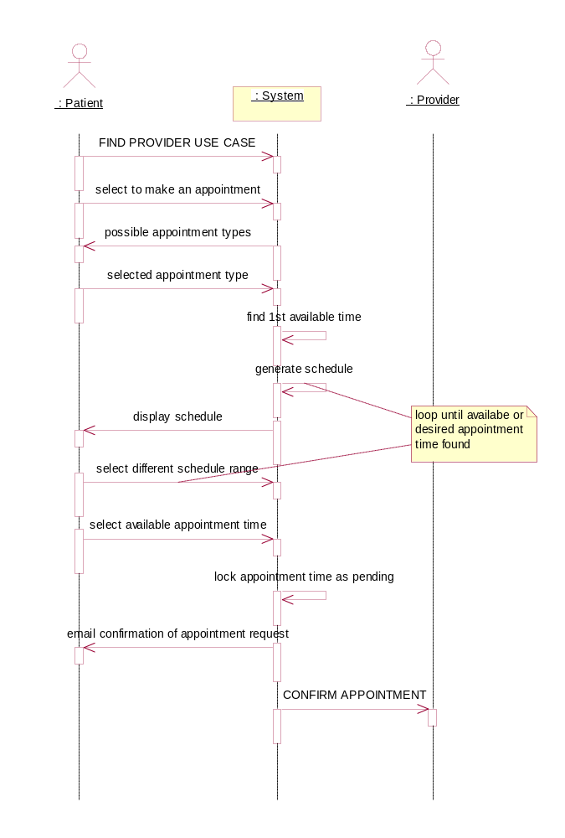
3.1.3.4 Outputs
A confirmation of the appointment request is displayed to the user, and a notification of an appointment request is sent to the Provider. Another patient viewing the schedule, would now see that block of time on the schedule represented as being a pending appointment.
3.1.3 Confirm Appointment

3.1.3.1 Introduction
The provider uses a web browser to approve or disapprove appointments that patients have requested.
3.1.3.2 Inputs
The provider can select to view all requested appointments in a list or upon viewing his schedule and marking the appointment(s) that he wants to approve or disapprove.
3.1.3.3 Processing
The system marks the appointment(s) as being approved or disapproved.
3.1.3.4 Outputs
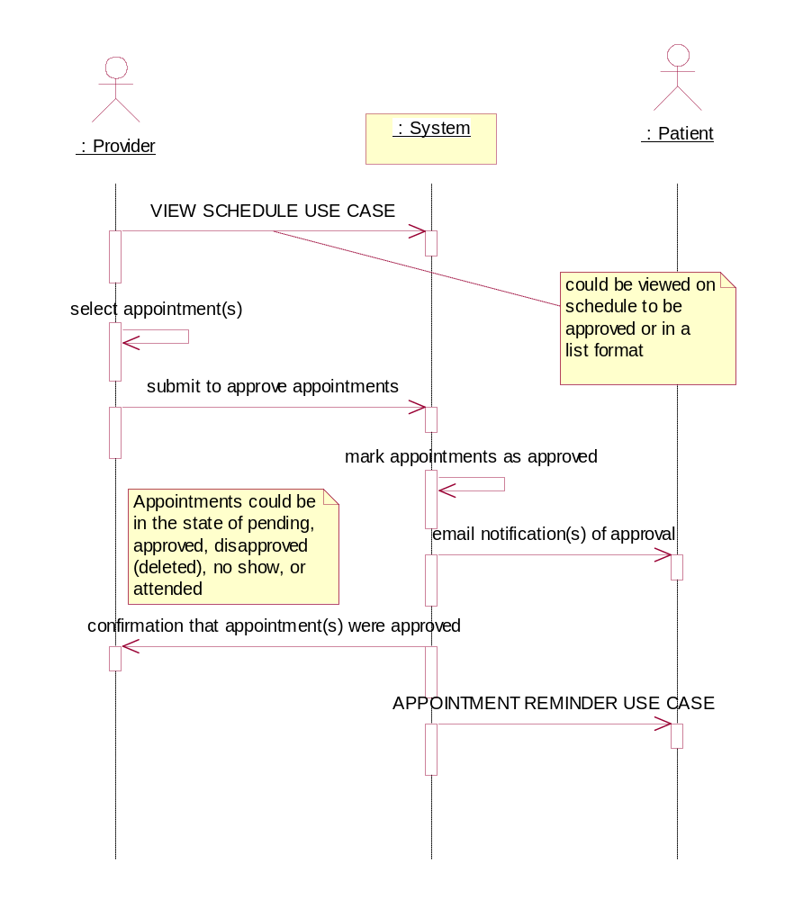
The provider receives a confirmation that the appointments were approved, and the patient receives an email notification that the appointment was approved. Another patient viewing the schedule would now see this block of time represented as an approved appointment.
3.1.3 Change Appointment

3.1.3.1 Introduction
This allows patients or providers to change an appointment. The following sequence diagram represents the provider initiating the change.
3.1.3.2 Inputs
The provider selects the appointment and submits the associated information to change.
3.1.3.3 Processing
The system modifies the appointment and changes its state.
3.1.3.4 Outputs
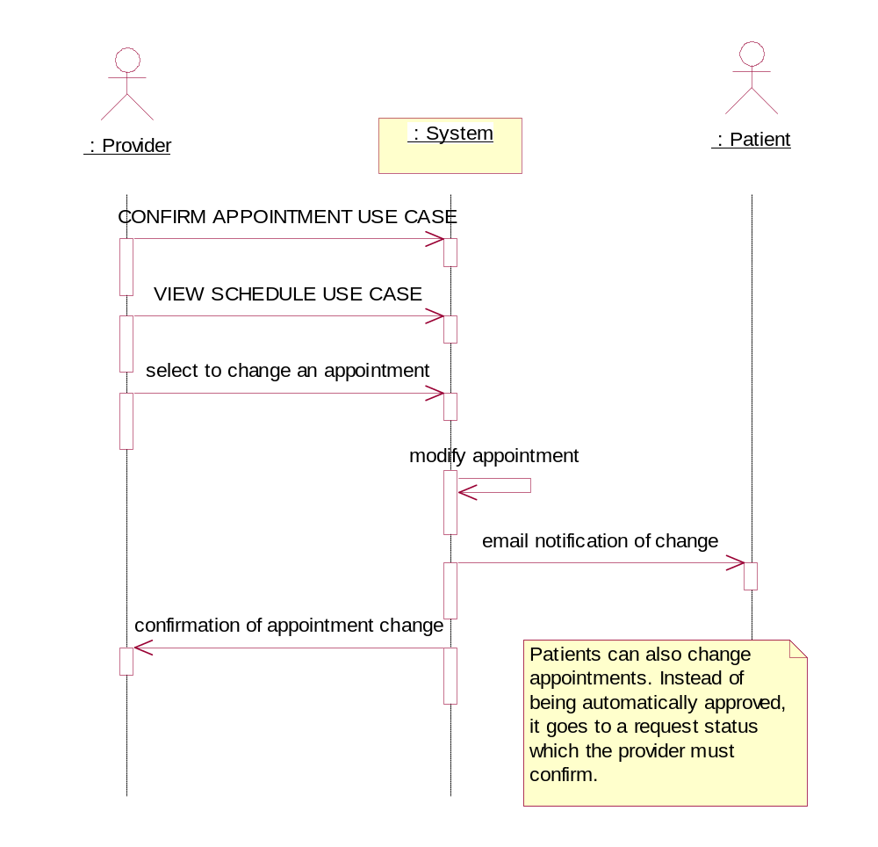
The patient receives an email notification of the change, and the provider receives confirmation that the change was submitted.
3.1.3 Cancel Appointment

3.1.3.1 Introduction
This allows patients or providers to cancel an appointment. The following sequence diagram represents the patient initiating to cancel.
3.1.3.2 Inputs
The patient selects to delete his or her appointment.
3.1.3.3 Processing
The system marks the appointment as cancelled.
3.1.3.4 Outputs
The provider is emailed a notification of the cancellation, and the patient is displayed a confirmation that it has been cancelled. The patient might ensue some fee for cancelling after a certain time period.
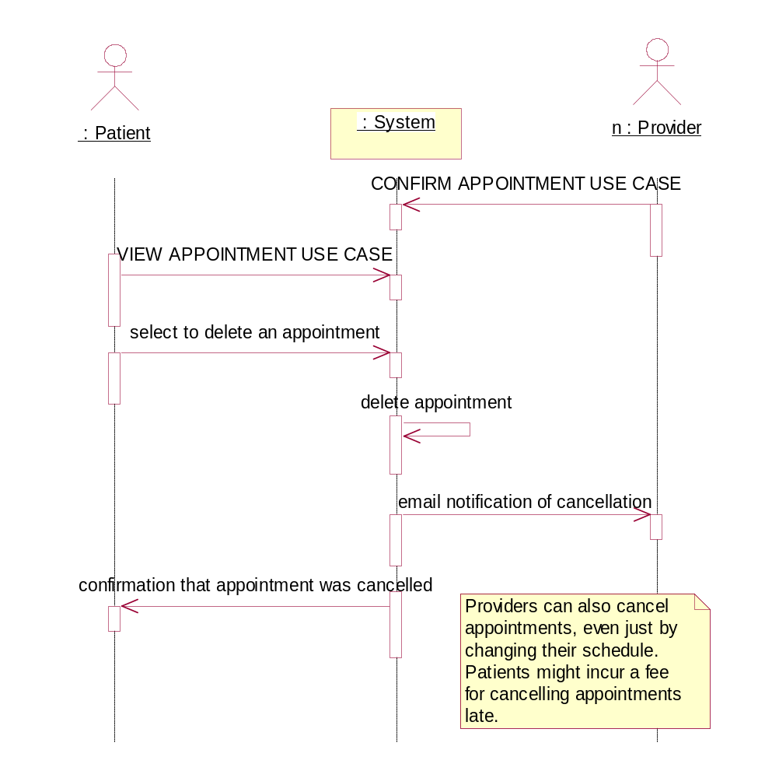
3.1.3 Appointment Reminder

3.1.3.1 Introduction
This use case is used to remind patients of upcoming appointments.
3.1.3.2 Inputs
This process is periodically initiated by the system based off of time during a low-use period of the system.
3.1.3.3 Processing
The system determines which appointments need reminders to be sent out, and if the patients have selected to have reminders sent.
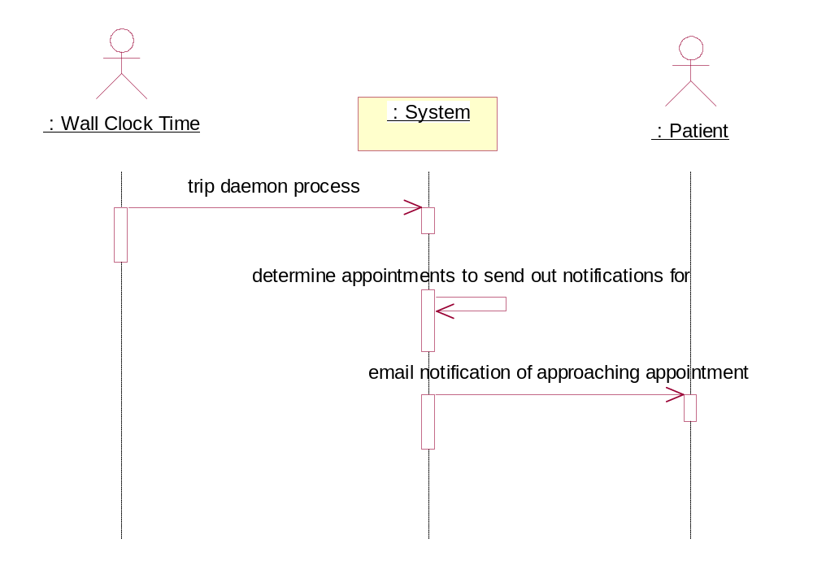
3.1.3.4 Outputs
The patient will receive an email notification of the upcoming appointment.
3.1.3 View Appointment

3.1.3.1 Introduction
The patient does this to view his appointment(s).
3.1.3.2 Inputs
A registered patient selects to view his or her appointments.
3.1.3.3 Processing
The system receives the patient’s appointment info.
3.1.3.4 Outputs
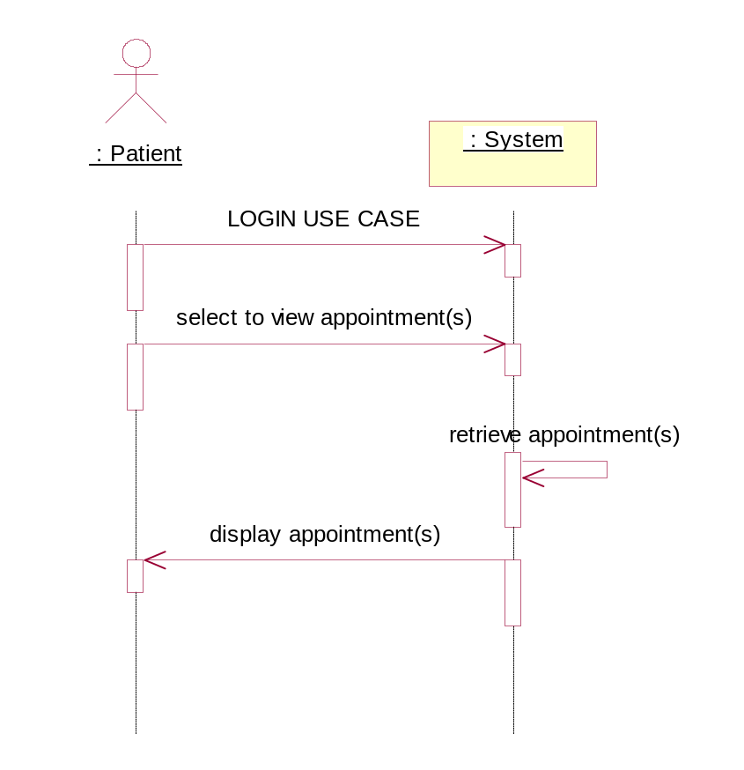
A dynamically generated page is displayed to the patient showing his or her past and upcoming appointments.
3.1.4 Create Profile

3.1.4.1 Introduction
The user shall be able to create a profile in the system. The profile shall consist of the user’s name, physical address, phone number, email address, username and password.

3.1.4.2 Inputs
User’s name, physical address, phone number, email address, username and password.

3.1.4.3 Processing
The system validates the username to make sure it is unique.

3.1.4.4 Outputs
Confirmation of profile creation to the screen and via email

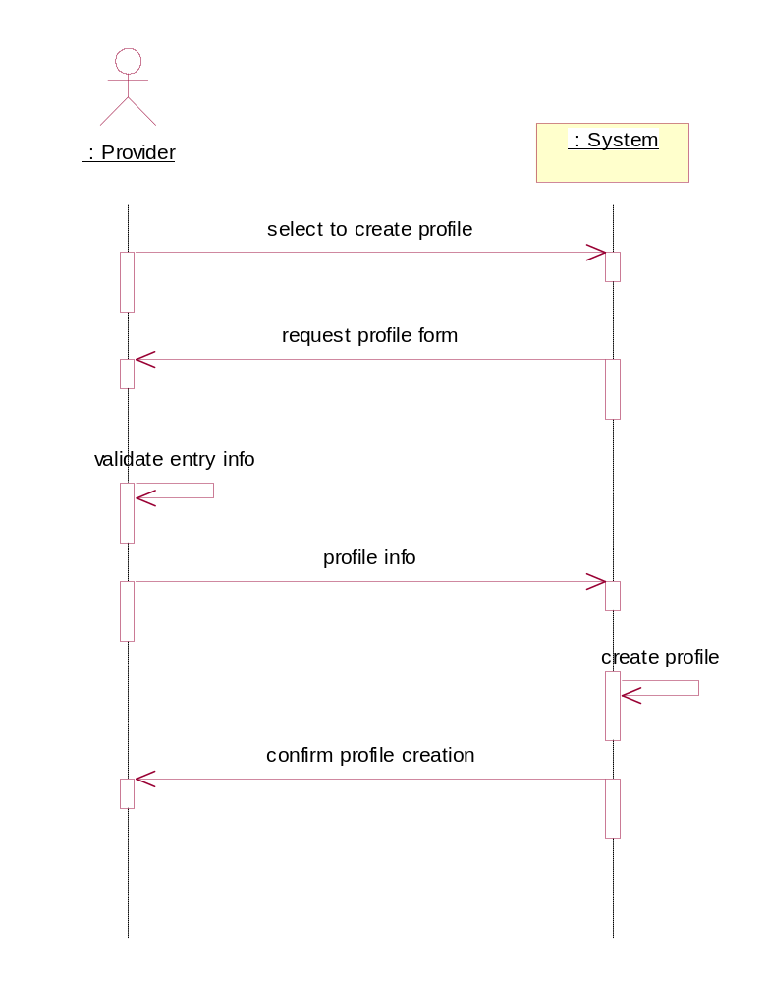
3.1.4 Login
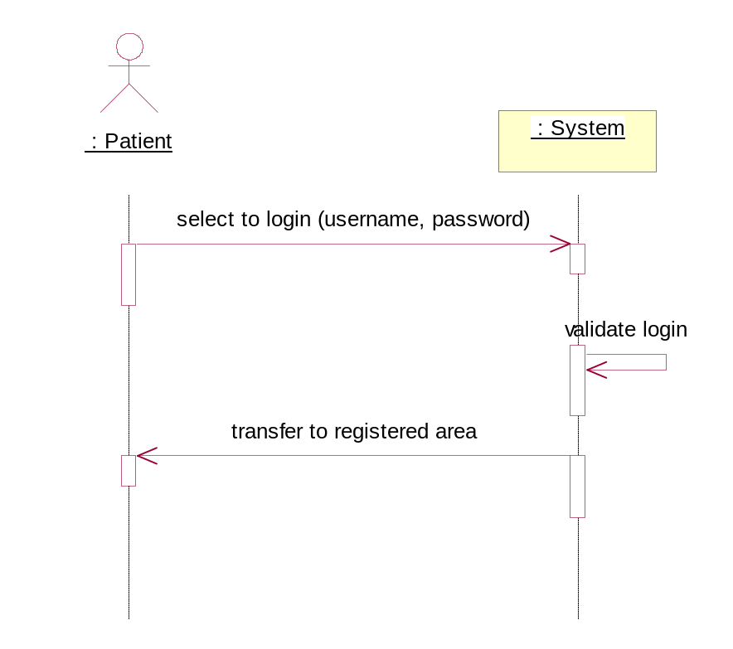

3.1.4.1 Introduction
The users shall be able to login to the system. Patients and Providers will log in using the same way, but will be taken to different screens once logged in.

3.1.4.2 Inputs
The user’s username and password

3.1.4.3 Processing
Check username and password against stored values.

3.1.4.4 Outputs
Login confirmation if username and password match. An error message if login fails.

3.1.4 Change Profile
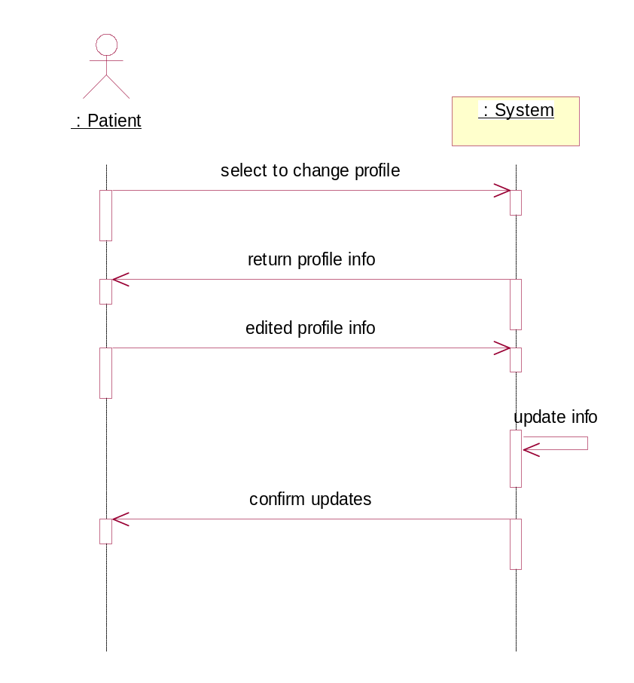

3.1.4.1 Introduction
Changing the profile is very similar to creating a profile

3.1.4.2 Inputs
The attributes to change and the values to change them to

3.1.4.3 Processing
Validate username to make sure it is unique if the user changed the username

3.1.4.4 Outputs
Confirmation of changed profile
3.2 Non-Functional Requirements

3.2.1 User interfaces
All user (Patient, Provider) interfaces are web-based HTML pages which can be accessed through any standard web browser. Web pages which ask for user input will include HTML forms. These HTML forms need to include JavaScript code to verify that the appropriate information has been input before allowing the information to be submitted to the web server. Web pages which provide confirmation information will be dynamically generated static HTML pages.

3.2.2 Hardware interfaces
There are not direct hardware interfaces in the system. The operating systems on both the client and server side will be configured to handle the hardware interfaces.

3.2.3 Software interfaces
The client side software interface will be through any standard web browser. The server side interface will be through a Java web server.

3.2.4 Communication interfaces
Communication between the client and servers will occur between the standard internet protocol HTTP. Mail transfers will be accomplished through SMTP.

3.2.5 Performance Requirements
Customers will be using this system to make important appointments. If the system is unresponsive customers will be lost. The response time for any operation shall be no longer than two (2) seconds not including internet latency. To test the response time a computer will be placed on a LAN with the server and perform operations.

3.2.6 Standards compliance
The system complies with the internet standards of HTML, HTTP, and MIME. These standards support the largest number of online customers.

3.2.7 Hardware limitations
There are no hardware limitations to be considered.

3.2.8 Software limitations
At this point in time it is not viable for epointment to purchase professional web hosting services. Because of this, files must be used for persistence of data to be used by the web server, instead of persisting the data to a DBMS. Another limitation is the use of a Java web server instead of an application server. Because of this, the system will have to incorporate its own online transaction processing services as well as handle concurrent access by multiple clients.

3.2.9 Environmental
The client side will run on any environment which supports a web browser. The server side environment will not be a concern to the clients, and can be upgraded/changed as necessary, without effecting the clients.

3.2.10 Availability
The system has to be available at all times.

3.2.11 Security
Epointment will possibly be handling sensitive medical/personal data so security is the utmost concern. Being able to prove to customers that the system is very secure will be essential for the future success of epointment. The system has to provide secure internet connections (SSL) for the transfer of private data. The web hosting service should provide security services so that third parties cannot modify the information hosted on the web site. Users will have to login to the system. Logging in will determine what level of access the user has with the system and the views with which they are provided. Security also means that user’s personal information shall be guarded very closely and all passwords shall be encrypted in the database.

3.2.12 Maintainability
The system should be completely remote administrable. This means that system statistics (avg transaction time, current active sessions, number of sessions processed in last hour/day/month) and system functions (start/stop system, reboot system, restart services etc..)

3.2.13 Transferability/conversion
There are no transferability concerns for the client side. The server side should be designed in such a manner so that the system can be transferred to a different web hosting service without effecting day to day operations.

3.2.14 Scalability
The system shall be designed so that is can easily be scaled to increase performance (response time). This means that the various tiers can be running on different processors on the same or different physical machines. This also means that the system shall be designed so that many instances of components can be running concurrently.

3.2.15 Reliability
The system shall be designed so that it can be completely reliable. Reliability comes in two forms: reliability in terms of the system always being up and reliability in perfect atomic transactions.

3.3 Other Requirements

3.3.1 Database
A database is not required from the offset. Files will be used to handle data storage.

3.3.2 Operations
Backups will be performed by both the owners and the administrators of the web hosting service.

3.3.3 Site adaptation
The site will be adaptable to the different users of the system, according to the access associated with the login that they provide.

